2018 May Day MCM

Problem A: Touring route design for Pan’an Lake scenic area of Xuzhou
General Secretary Xi Jinping pointed out that support will be given to resource-depleted areas in their economic transformation at the 19th National Congress of the Communist Party of China. President Xi came to Xuzhou city for investigation on December 12 to 13, 2017, which is the first survey of President Xi after the 19th National Congress of the Communist Party of China. He emphasized that the subsidence area should stick to the way of economic transformation, which is suitable for national conditions.

Xuzhou is an old industrial and resource city with a long history of coal mining for 130 years. There emerged about hundreds of thousands mu coal mining subsidence areas due to long-term coal mining in Xuzhou. For example, the Pan’an lake locates in the southwest of Jiawang District of Xuzhou, which was used to be the most serious subsidence area. According to some statistics, Jiawang coal field has provided more than 350 million tons of raw coal since 1949. However, it also caused land subsidence of 11300 mu. In 2010, the largest single investment project of land consolidation was started in Pan’an lake, some measures were adopted to build a water conservancy area with the size of 6500 mu on the ruins. In 2016, Jiawang was established as one of the first batch “National regional tourism demonstration area” in China. There are about 5.6 million tourists during the year 2016 and the tourism revenue is about 1.68 billion yuan. Under the following assumptions, please design some touring routes for visiting scenic spots of Pan’an lake scenic area in Xuzhou as shown in Figure 1.

Assumptions:
- The shortest walking distance between different scenic spot is shown in Table 1.
- The walking speed is assumed to be 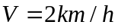 in question 2 and 3.
- The total time in the scenic area consists of three components as follows:
- The walking time between different scenic spots.
- The visiting time inside the scenic spot
- The waiting time outside the scenic spot
Any other times are ignored and the visiting time must meet the requirements as shown in Table 2.

1. Start from the original scenic spot (Jingshi), and walk through the following scenic spots: (1) Tourist service center; (2) Sunny lawn; (3) Forest theater; (4) The area of children’s science popularization; (5) Children’s swimming pool; (6) Wetland museum; (7) Wetland commercial street. Please establish a mathematical model to find out the shortest route, which needs to travel all the mentioned scenic spots at least one time. Then, calculating the length of the shortest route and filling in Table 3. Note: Do not need to stop at each scenic spot.

2. If a tourist starts from the original scenic spot (Jingshi) at 12:00. Then, he needs to reach the wetland commercial street before 17:00 and leave the wetland commercial street at 17:30 (Note: The least travel time at wetland commercial street is 30 minutes as shown in Table 2). How to establish the mathematical model and design a route with the maximum visiting time, which needs to visit all the scenic spots (Assume that the tourist does not need to wait at each scenic spot). The results are needed to be filled in Table 4.

3. If there are three touring groups starting from the original scenic spot (Jingshi) at 12:00. Then, they need to reach the wetland commercial street before 17:00 and leave the wetland commercial street at 17:30 (Note: The least travel time at wetland commercial street is 30 minutes as shown in Table 2). Meanwhile, each scenic spot (except wetland commercial street) can only contain one touring group according to the principle of first-come first-served. Please establish a mathematical model and design three routes for the touring groups with maximum visiting time (It needs to visit all the 7 scenic spots), respectively. Then, complete the Table 5.

4. Assuming that the walking speed of the three touring groups can be adjusted between 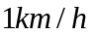 and 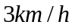. However, the average speed can not exceed 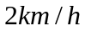. If there are three touring groups starting from the original scenic spot (Jingshi) at 12:00. Then, they need to reach the wetland commercial street before 17:00 and leave the wetland commercial street at 17:30 (Note: The least travel time at wetland commercial street is 30 minutes as shown in Table 2). Meanwhile, each scenic spot (except wetland commercial street) can only contain one touring group according to the principle of first-come first-served. Please establish a mathematical model and design three routes for the touring groups with maximum visiting time (it needs to visit all the scenic spots), respectively. Then, complete the Table 6.

5. In reality, considering the following two uncertainty factors:
- The departure time of different touring groups from original scenic spot (Jingshi) is uncertain. For example, some touring groups departure at different times from original scenic spot (Jingshi). Under this circumstance, the arrival time at the wetland commercial street need to postpone accordingly.
- The waiting time at each scenic spot is uncertain. For example, the maintenance of tourism facilities and tourism facilities cleaning for a short period time, or the influence of individual passenger flow.
Other conditions are the same as those in question 4, how to establish a mathematical model and design three routes for the touring groups with maximum visiting time and minimum waiting time considering the above two uncertainty factors (It needs to visit all the scenic spots), respectively.
Figure 1 The map of some of scenic spots in Pan’an lake scenic area
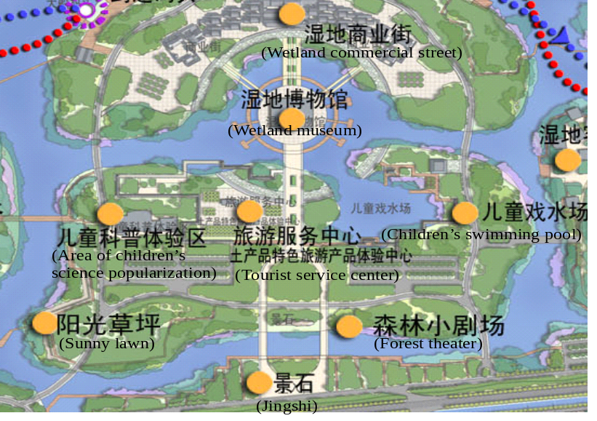

Table 1 The shortest walking distance between different scenic spot (meter)
 | Jingshi | Tourist service center | Sunny lawn | Forest theater | Area of children’s science popularization | Children’s swimming pool | Wetland museum | Wetland commercial street
Jingshi | 0 | 300 | 360 | 210 | 590 | 475 | 500 | 690
Tourist service center | 300 | 0 | 380 | 270 | 230 | 285 | 200 | 390
Sunny lawn | 360 | 380 | 0 | 510 | 230 | 765 | 580 | 770
Forest theater | 210 | 270 | 510 | 0 | 470 | 265 | 450 | 640
Area of children’s science popularization | 590 | 230 | 230 | 470 | 0 | 515 | 260 | 450
Children’s swimming pool | 475 | 285 | 765 | 265 | 515 | 0 | 460 | 650
Wetland museum | 500 | 200 | 580 | 450 | 260 | 460 | 0 | 190
Wetland commercial street | 690 | 390 | 760 | 640 | 450 | 650 | 190 | 0

Table 2 The tour time of each scenic spot
Time  Scenic spot | Tour time | Opening time
Tourist service center | 10-30 minutes | 9:00-16:00
Sunny lawn | 20-60 minutes | 9:00-17:00
Forest theater | 30 minutes | 9:00, 9:30, 10:00, 10:30, 11:00, 11:30, 12:00, 12:30, 13:00, 13:30, 14:00, 14:30, 15:00, 15:30, 16:00, 16:30, 17:00
Area of children’s science popularization | 30-60 minutes | 9:00-17:00
Children’s swimming pool | 20-60 minutes | 9:00-17:00
Wetland museum | 30-60 minutes | 9:00-17:00
Wetland commercial street | More than 30 minutes | 9:00-21:30

Table 3 The results of question 1
Departure scenic spot | Arrival scenic spot | Walking distance(meter)
Jingshi
 | Wetland commercial street
Total walking distance(The length of shortest route)
The shortest route(Mark it with the following number ①~⑥) |  | Jingshi→……→⑦
Note: add or delete the rows in this table if necessary

Table 4 The results of question 2
No. | Names of scenic spots | Arrival time | Visiting time(minute) | Leaving time
1 | Jingshi | 12:00 | 0 | 12:00
2
3
4
5
6
7
8 | Wetland commercial street |  |  | 17:30
Total visiting time in the scenic area： Minutes
Total walking time： Minutes

Table 5 The results of question 3
 | The first touring group |  |  | The second touring group |  |  | The third touring group
 | Arrival time | Visiting time(minute) | Leaving time | Arrival time | Visiting time(minute) | Leaving time | Arrival time | Visiting time(minute) | Leaving time
Jingshi | 12:00 | 0 | 12:00 | 12:00 | 0 | 12:00 | 12:00 | 0 | 12:00
Tourist service center
Sunny lawn
Forest theater
Area of children’s science popularization
Children’s swimming pool
Wetland museum
Wetland commercial street |  |  | 17:30 |  |  | 17:30 |  |  | 17:30
Total walking time | Minutes |  |  | Minutes |  |  | Minutes
Total visiting time | Minutes |  |  | Minutes |  |  | Minutes
Total waiting time | Minutes |  |  | Minutes |  |  | Minutes

Table 6 The results of question 4
 | The first touring group |  |  |  | The second touring group |  |  |  | The third touring group
 | Arrival time | Visiting time  (minute) | Leaving time | The speed at the arrival of next scenic spot  (km/h) | Arrival time | Visiting time  (minute) | Leaving time | The speed at the arrival of next scenic spot(km/h) | Arrival time | Visiting time  (minute) | Leaving time | The speed at the arrival of next scenic spot(km/h)
Jingshi | 12:00 | 0 | 12:00 |  | 12:00 | 0 | 12:00 |  | 12:00 | 0 | 12:00
Tourist service center
Sunny lawn
Forest theater
Area of children’s science popularization
Children’s swimming pool
Wetland museum
Wetland commercial street |  |  | 17:30 |  |  |  | 17:30 |  |  |  | 17:30
Total walking time | Minutes |  |  |  | Minutes |  |  |  | Minutes
Total visiting time | Minutes |  |  |  | Minutes |  |  |  | Minutes
Total waiting time | Minutes |  |  |  | Minutes |  |  |  | Minutes
Average speed | km/h |  |  |  | km/h |  |  |  | km/h

